Agentic Multi-Specialized AI Organization Paper
Date: March 22, 2026

Table of Contents
Executive Summary
Architecture
Implementation

Executive Summary
Analysis of organizational structures for multi-specialized AI teams with implementation strategies.

Architecture

Implementation

Architecture
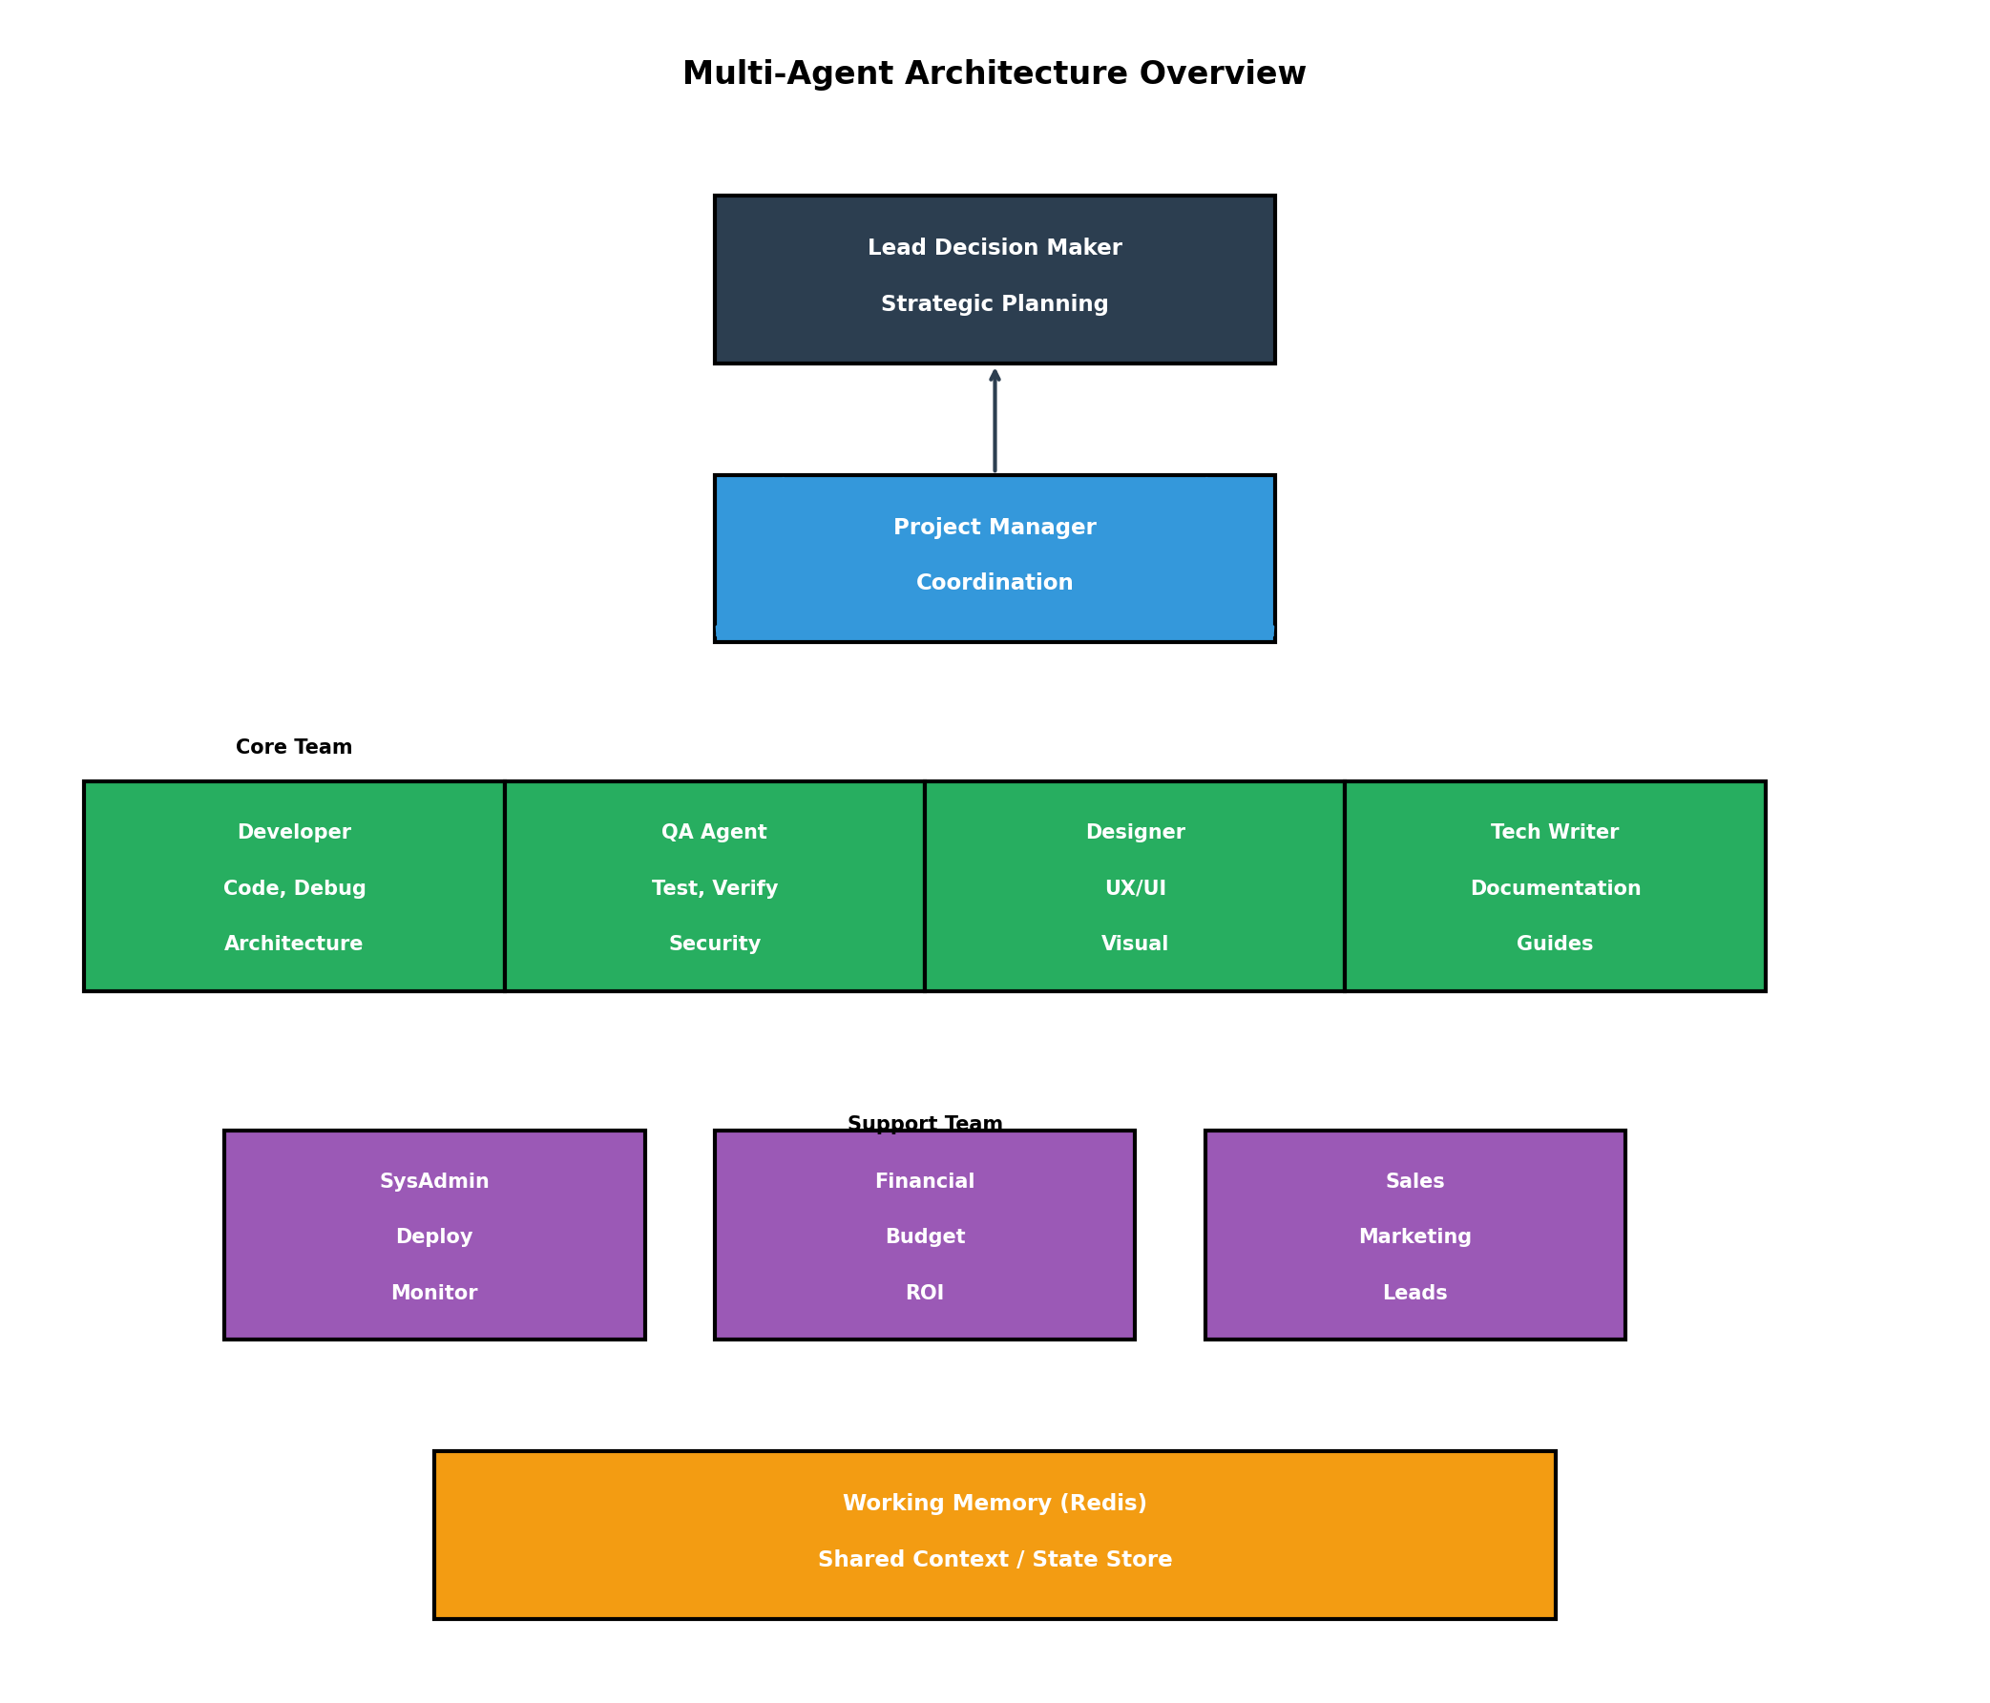

Timeline
