Multi-Specialized Agentic AI Proposal
Date: March 22, 2026

Table of Contents
Executive Summary
Key Findings
Architecture Overview
Cost Analysis
Productivity Comparison
Quality Metrics
Implementation Timeline
ROI Projection
Conclusion

Executive Summary
This paper proposes a multi-specialized agentic AI approach where individual AI agents, each optimized for specific domains, collaborate as a complete development organization. Based on extensive real-world project work documented in the STSGYM repository, we demonstrate that a single human operator with specialized AI agents can achieve outcomes equivalent to a traditional 10-15 person development team at 93-98% lower cost.

Key Findings

Architecture Overview

Cost Analysis

Productivity Comparison

Quality Metrics

Implementation Timeline

ROI Projection

Conclusion
The multi-specialized agentic AI approach represents a fundamental shift in how software development organizations operate. By enabling a single human to leverage specialized AI agents across all traditional roles, organizations can achieve unprecedented efficiency gains while maintaining quality and accelerating time-to-market.

Cost Comparison
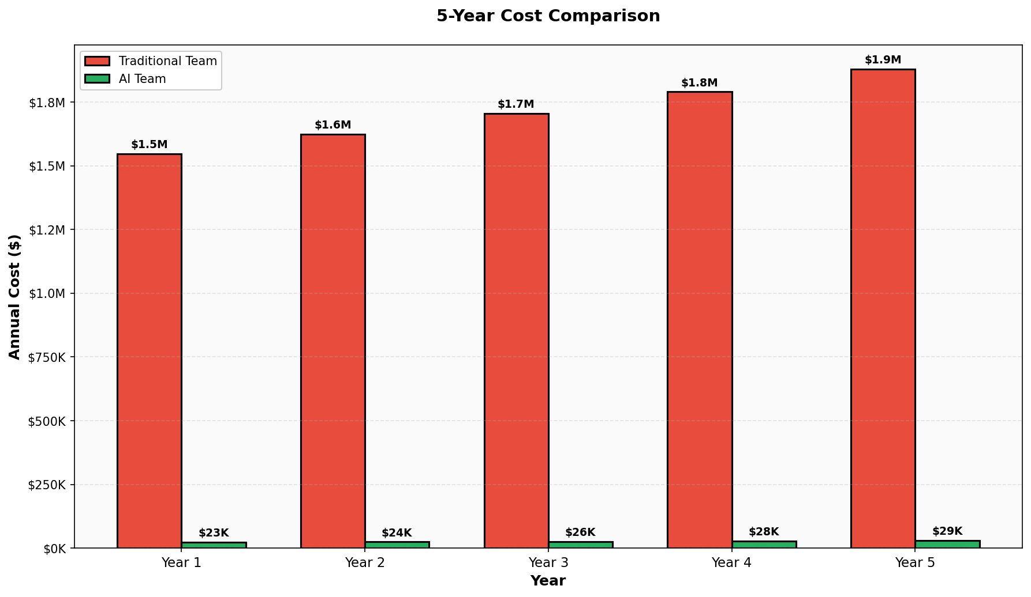

Architecture Overview
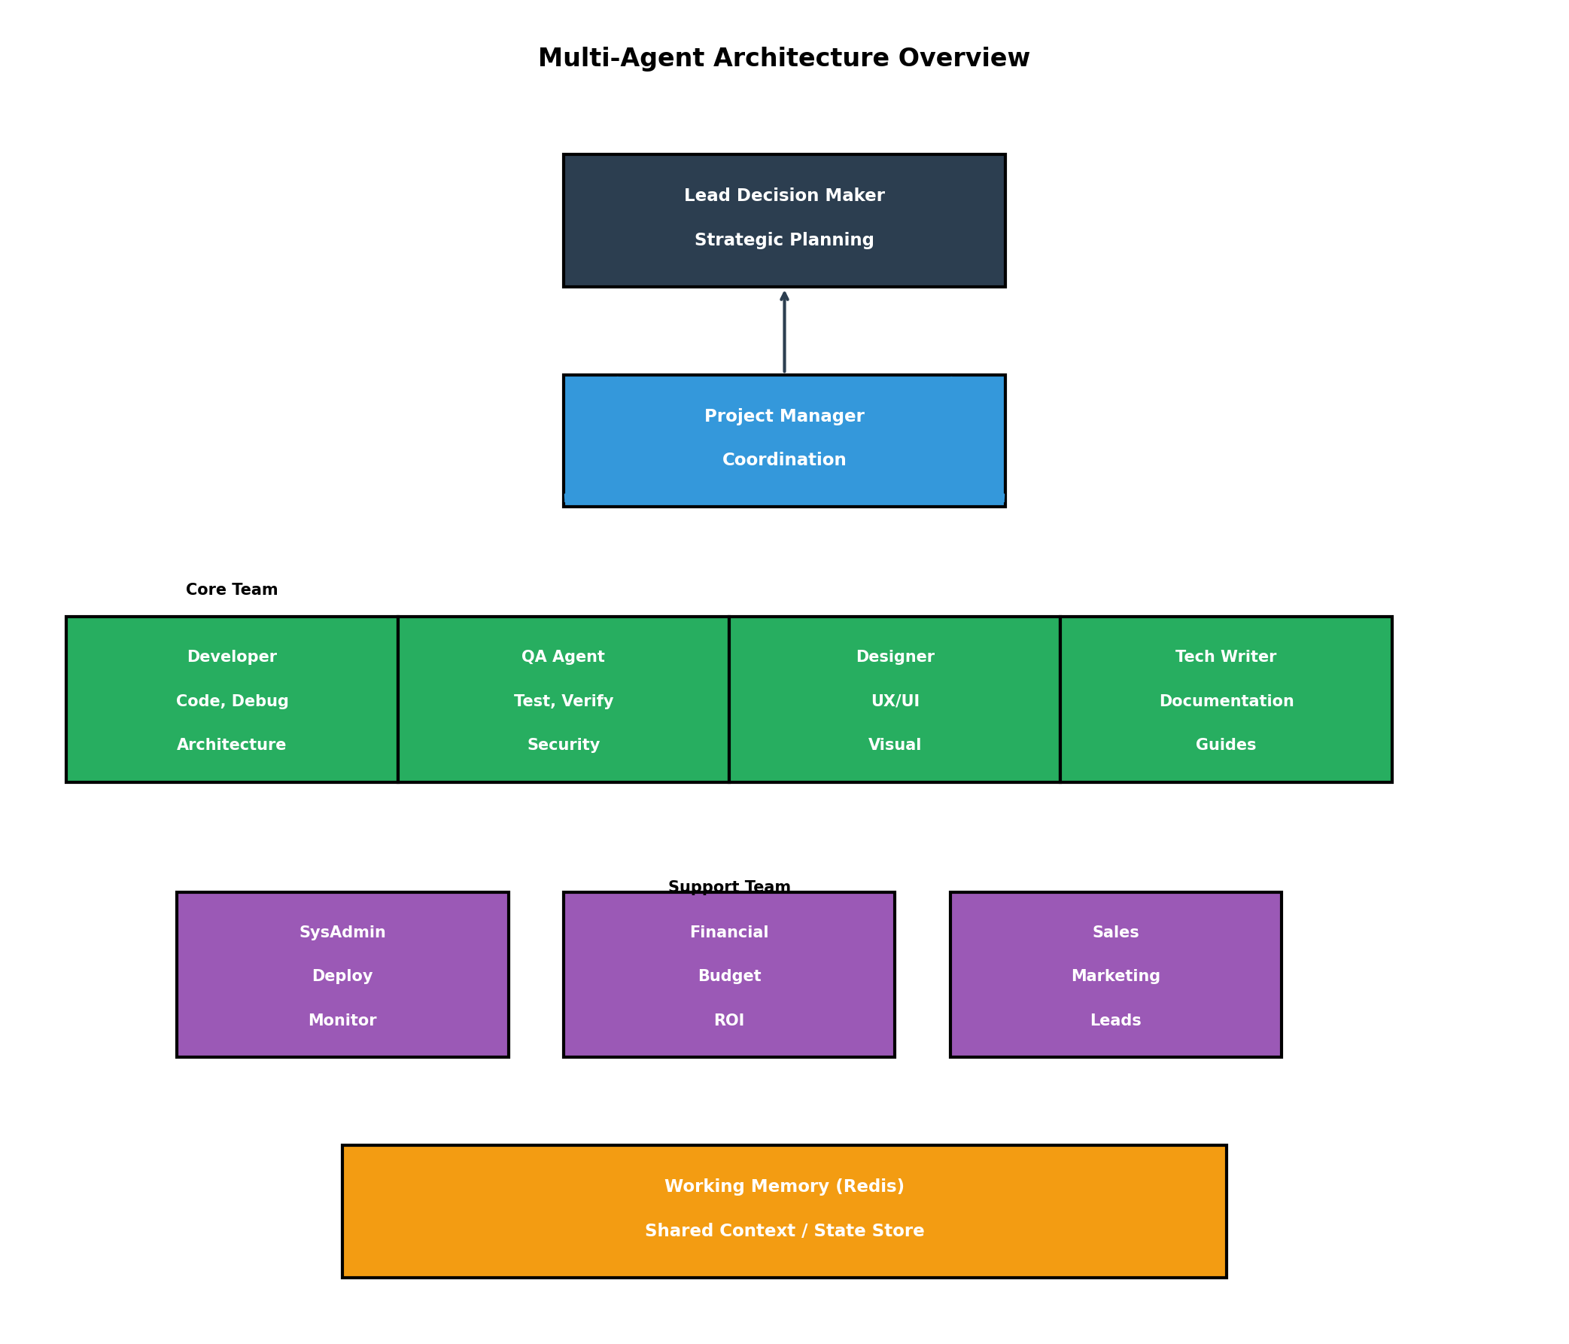

Productivity Comparison
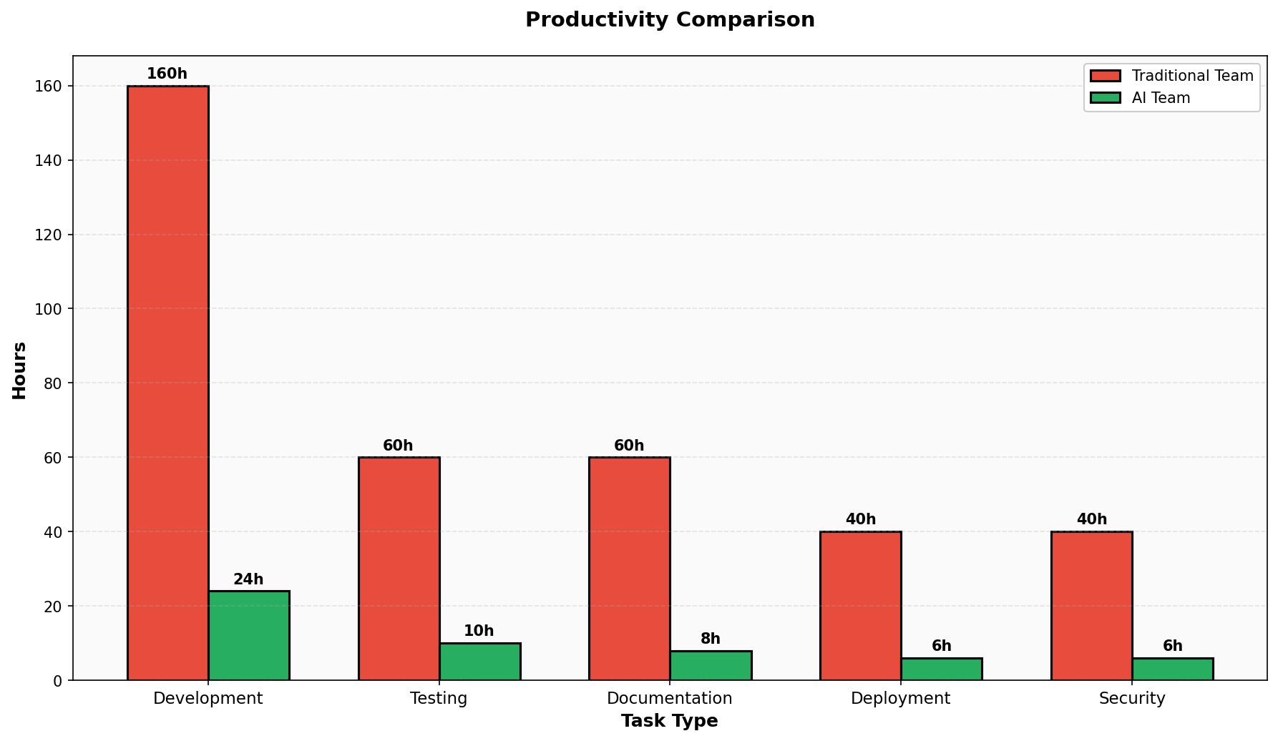

Quality Metrics
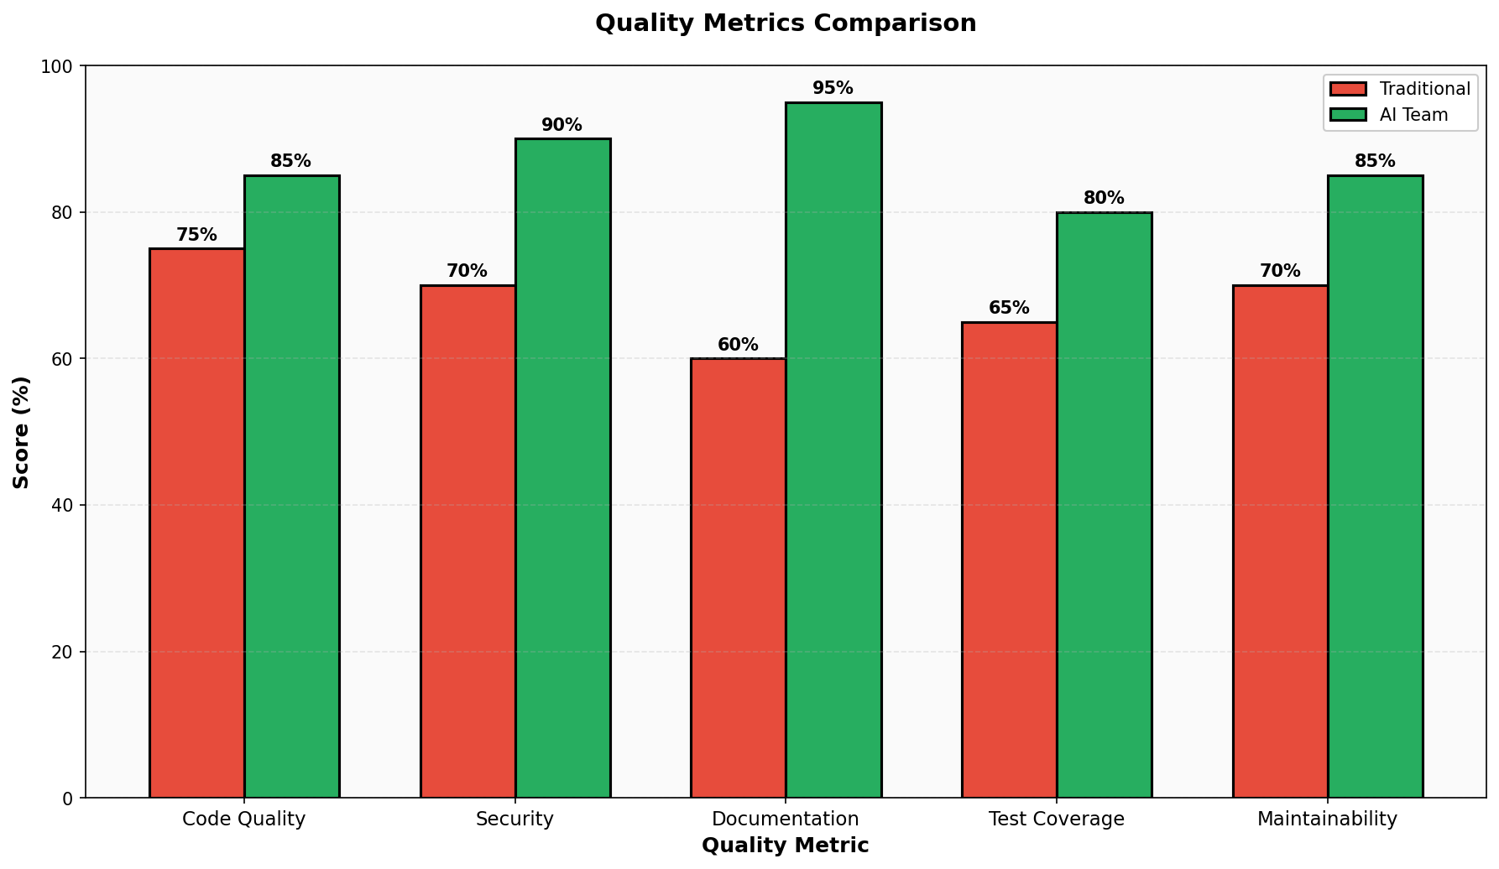

Implementation Timeline
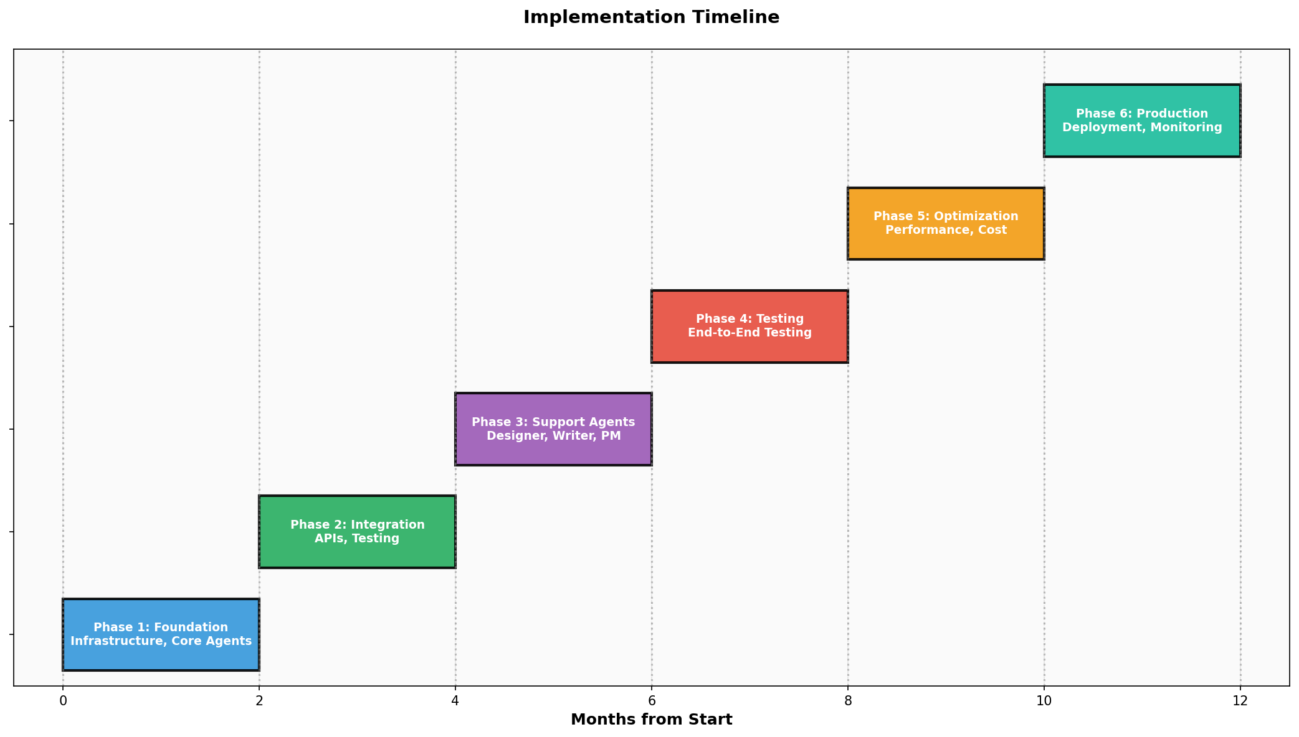

ROI Projection
