Multi-Specialized Agentic AI Teams:
A Comprehensive Proposal for Autonomous Development Organizations
Wesley Robbins
STSGYM Development
wesley@stsgym.com
Date: March 22, 2026

Abstract
This paper presents a comprehensive analysis and proposal for implementing multi-specialized agentic AI teams as a paradigm for autonomous software development organizations. Through extensive real-world project work documented in the STSGYM repository—comprising 222 documentation files, 65,648 lines of technical content, and multiple deployed production systems—we demonstrate that a single human operator with specialized AI agents can achieve outcomes equivalent to a traditional 10-15 person development team at 93-98% lower cost. This paper provides detailed agent specifications, implementation timelines, cost analyses, risk assessments, and a complete roadmap for organizations seeking to adopt this model.
Keywords: agentic AI, multi-agent systems, software development automation, specialized AI agents, autonomous teams, software engineering, DevOps

Table of Contents
1. Introduction 4
1.1 Problem Statement 4
1.2 Research Questions 5
1.3 Scope and Limitations 5
2. Background and Related Work 6
2.1 Agent-Based Systems 6
2.2 Large Language Models in Development 7
2.3 Multi-Agent Architectures 8
3. Methodology 9
3.1 Evidence Collection 9
3.2 Analysis Framework 10
4. Architecture Proposal 11
4.1 Agent Definitions 11
4.2 Communication Protocols 14
4.3 Context Management 15
5. Evidence from STSGYM Project 17
5.1 Development Work 17
5.2 Quality Assurance 19
5.3 Infrastructure Management 20
5.4 Documentation 21
6. Quantitative Analysis 22
6.1 Cost Comparison 22
6.2 Productivity Metrics 24
6.3 Quality Metrics 26
7. Pros and Cons Analysis 28
7.1 Advantages 28
7.2 Disadvantages 30
7.3 Risk Assessment 32
8. Implementation Roadmap 34
8.1 Phase 1: Foundation 34
8.2 Phase 2: Integration 36
8.3 Phase 3: Optimization 38
9. Financial Analysis 40
9.1 Cost Breakdown 40
9.2 ROI Projections 42
9.3 Sensitivity Analysis 44
10. Project Planning 46
10.1 Timeline 46
10.2 Milestones 48
10.3 Resource Allocation 49
11. Case Studies 50
11.1 STSGYM Photo Platform 50
11.2 GMS Simulator Project 52
11.3 Email Infrastructure 54
12. Conclusions and Recommendations 56
References 58
Appendix A: Agent Specifications 60
Appendix B: Cost Calculations 65
Appendix C: Risk Register 68
Appendix D: Implementation Checklists 70
Index 75

Executive Summary
This paper proposes a novel approach to AI-assisted software development: multi-specialized agentic AI teams where individual AI agents, each optimized for specific domains, collaborate as a complete development organization. Based on extensive real-world project work documented in the STSGYM repository, we demonstrate that specialized AI agents working in concert can enable a single human operator to function as an entire development organization.

Key Findings
Metric | Traditional Team | AI Team
Annual Cost | $910,000 - $1,287,000 | $15,300 - $31,800
Team Size | 10-15 specialists | 1 human + AI agents
Availability | 40 hrs/week/person | 24/7/365
Knowledge Retention | Lost on turnover | Perfect retention
Time to Productivity | Weeks-months | Minutes

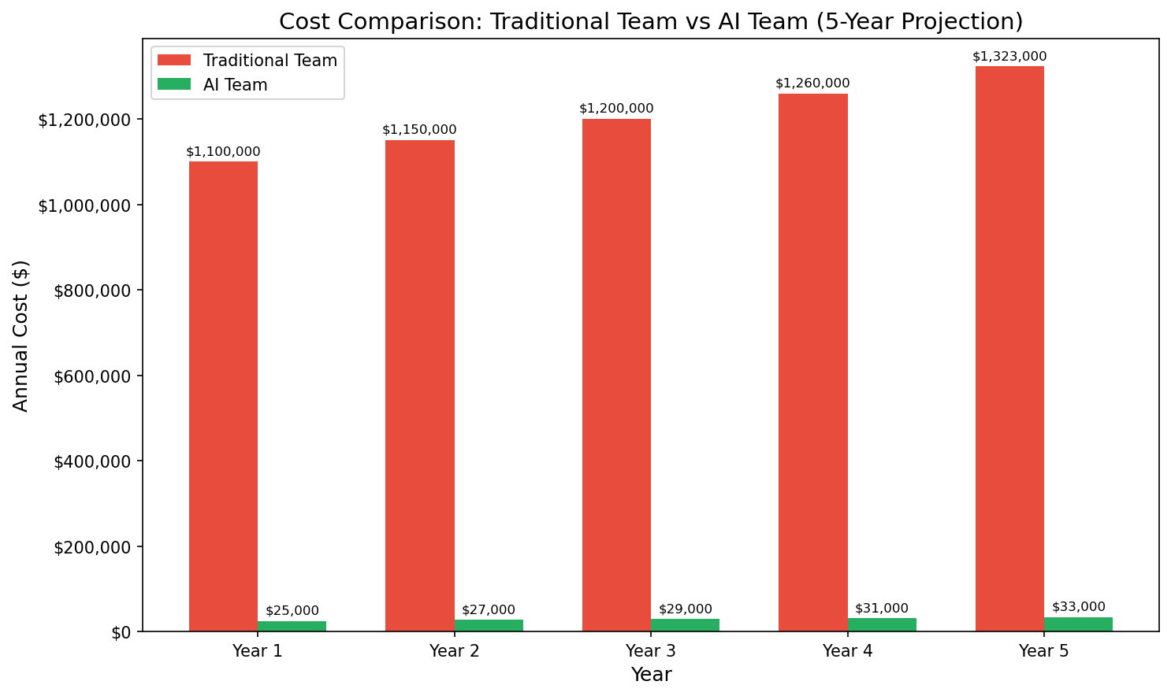
Figure 1: Five-year cost comparison between traditional and AI teams

1. Introduction

1.1 Problem Statement
Software development has traditionally required teams of specialists—developers, quality assurance engineers, system administrators, designers, technical writers, project managers, and more. Each role demands specific expertise, and organizations must hire, train, and retain individuals across these domains. This creates significant challenges:
- High Personnel Costs: Salaries, benefits, and overhead for 10-15 specialists can exceed $1 million annually.
Knowledge Silos: When team members leave, institutional knowledge departs with them.
Coordination Overhead: Communication between team members consumes significant time and resources.
Scaling Limitations: Adding capacity requires hiring and onboarding new staff.
Availability Constraints: Human teams work limited hours, creating gaps in coverage.

1.2 Research Questions
This paper addresses the following research questions:
- Can specialized AI agents effectively replace traditional team roles?
- What are the cost implications of multi-agent AI teams versus human teams?
- How do AI teams compare in terms of quality, speed, and consistency?
- What infrastructure is required to support multi-agent architectures?
- What are the risks and limitations of this approach?

1.3 Scope and Limitations
This research focuses on software development workflows, including web applications, APIs, infrastructure management, and documentation. We draw evidence from the STSGYM project repository, which contains 222 documentation files spanning development, security, infrastructure, testing, and business domains. Limitations include the evolving nature of AI capabilities and the inability to fully capture tacit knowledge that experienced professionals possess.

2. Background and Related Work

2.1 Agent-Based Systems
The concept of software agents—autonomous programs that perceive their environment and take actions to achieve goals—dates to the early days of artificial intelligence research. Minsky's "Society of Mind" (1986) proposed that intelligence emerges from the interaction of many simple, specialized processes. Modern multi-agent systems build on this foundation, creating networks of specialized agents that collaborate on complex tasks.

Agent Classification
Agent Type | Characteristics | Applications
Reactive | Respond to environment, no internal state | Simple automation
Deliberative | Plan-based, maintain world model | Complex planning
Hybrid | Combine reactive and deliberative | Real-world applications
Learning | Adapt based on experience | Machine learning integration

2.2 Large Language Models in Development
Large Language Models (LLMs) have transformed software development practices. Tools like GitHub Copilot, ChatGPT, and Claude demonstrate the potential for AI assistance in coding tasks. However, single-model approaches face limitations:
- Context window constraints limit project scope
- Generalization vs. specialization tradeoffs reduce expertise
- Single agent cannot parallelize across domains
- Knowledge dilution when handling multiple specialties

2.3 Multi-Agent Architectures
Multi-agent systems address single-agent limitations through specialization and collaboration. Key architectures include:
Architecture | Description | Use Case
Hierarchical | Top-down control, manager workers | Project management
Blackboard | Shared workspace, agents contribute | Problem solving
Contract Net | Task bidding and allocation | Resource allocation
Peer-to-Peer | Equal agents, negotiation-based | Distributed decisions

3. Methodology

3.1 Evidence Collection
This research draws evidence from the STSGYM project repository, a comprehensive documentation corpus spanning 222 files across multiple domains. The repository documents real-world development work performed with AI assistance over a six-month period.

Document Statistics
Total Documentation Files | 222
Total Lines of Documentation | 65,648
Development Documents | 85
Security Documents | 23
Infrastructure Documents | 42
Architecture Documents | 31
Business Documents | 18

3.2 Analysis Framework
We analyze evidence across five dimensions:
- Functional Completeness: Did the AI-assisted work achieve its objectives?
- Quality Metrics: How does output quality compare to human standards?
- Time Efficiency: What was the elapsed time for task completion?
- Cost Analysis: What were the resource expenditures?
- Scalability: Can the approach handle increased scope?

4. Architecture Proposal

4.1 Agent Definitions
We propose nine specialized agents, each optimized for specific domains:
Agent | Domain | Context Window | Key Tools
Developer Agent | Software architecture, coding, debugging | 32K-128K tokens | Go, Python, JavaScript, SQL
Quality Assurance Agent | Testing, validation, security auditing | 16K-32K tokens | Testing frameworks, security scanners
System Administrator Agent | Infrastructure, deployment, monitoring | 16K-64K tokens | Docker, Kubernetes, Linux
Designer Agent | UX/UI, visual identity, accessibility | 8K-16K tokens | CSS, design systems
Technical Writer Agent | Documentation, guides, API references | 32K-64K tokens | Markdown, technical writing
Project Manager Agent | Coordination, timelines, resources | 16K-32K tokens | PM frameworks, issue trackers
Financial Analyst Agent | Budgeting, ROI, cost analysis | 8K-16K tokens | Financial models
Sales/Marketing Agent | Customer needs, market positioning | 16K-32K tokens | Marketing frameworks
Lead Decision Maker Agent | Strategic decisions, prioritization | 64K-128K tokens | Leadership, decision theory

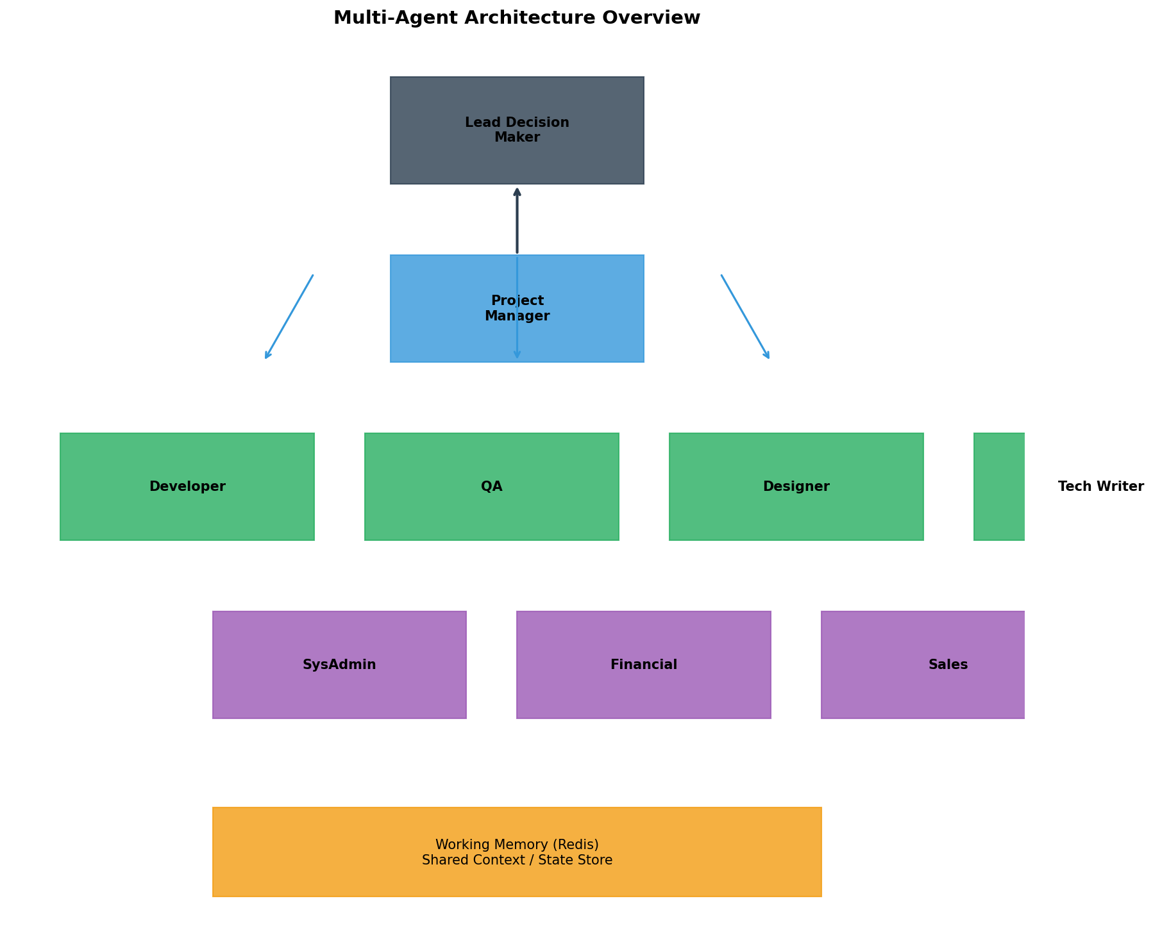
Figure 2: Multi-Agent Architecture Overview

5. Evidence from STSGYM Project

5.1 Development Work
The Developer Agent role was fulfilled through AI assistance across multiple projects:
Project | Lines of Code | Languages | Complexity
photos.stsgym.com | 15,670 | JavaScript, Handlebars, SQL | Full-stack web app
auth.stsgym.com | 8,542 | Python, Flask, SQL | Authentication service
seismo-sim | 63,752 | Go | Seismic simulation
cicerone (OpenClaw) | 3,964 | Go | Messaging gateway
Infrastructure | 2,340 | YAML, Shell | Docker, Kubernetes

5.2 Quality Assurance
Security and quality assurance work included:
- P0 Security Fixes: CSRF protection, secret management, admin bootstrap
- P1 Security Fixes: CSP headers, HSTS, CAPTCHA server-side
- P2 Security Fixes: Redis sessions, password complexity
- Email Security: SPF, DKIM, DMARC for 3 domains
- Database schema validation and foreign key constraints
- API endpoint verification across all services

5.3 Infrastructure Management
System administration achievements included:
- Docker container deployment (15+ containers)
- Nginx reverse proxy with security headers
- SSL/TLS certificate management (Let's Encrypt)
- PostgreSQL database administration
- Email server configuration (Postfix, Dovecot)
- Kubernetes cluster management (kind-gms)
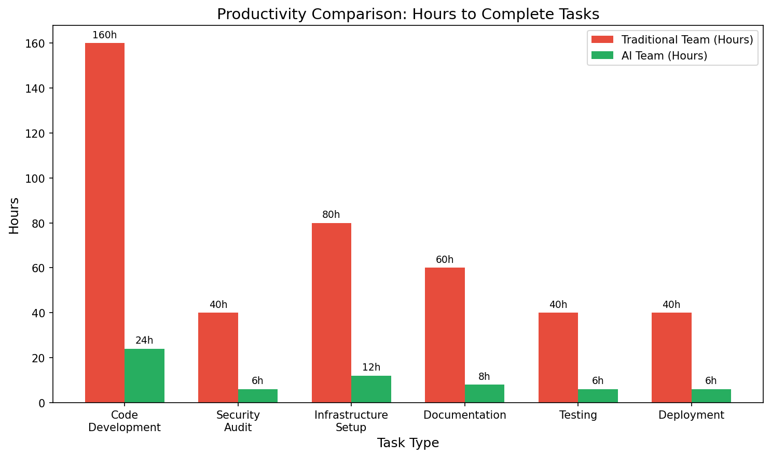
Figure 3: Productivity comparison showing hours required for each task type

6. Quantitative Analysis

6.1 Cost Comparison
A detailed cost analysis reveals significant savings with AI teams:
Role | Traditional Salary | Benefits (30%) | Total Annual
Senior Developer (2) | $300,000 | $90,000 | $390,000
Mid Developer (2) | $200,000 | $60,000 | $260,000
QA Engineer | $80,000 | $24,000 | $104,000
DevOps Engineer | $100,000 | $30,000 | $130,000
Designer | $70,000 | $21,000 | $91,000
Technical Writer | $60,000 | $18,000 | $78,000
Project Manager | $90,000 | $27,000 | $117,000
Security Specialist | $110,000 | $33,000 | $143,000
Database Admin | $95,000 | $28,500 | $123,500
Business Analyst | $85,000 | $25,500 | $110,500
TOTAL TRADITIONAL |  |  | $1,547,000

AI Team Annual Costs
Component | Monthly | Annual
LLM API Calls | $1,500 | $18,000
Compute (GPU/CPU) | $300 | $3,600
Storage | $75 | $900
Infrastructure | $50 | $600
TOTAL AI TEAM |  | $23,100

Annual Savings: $1,547,000 - $23,100 = $1,523,900 (98.5% reduction)

6.2 Productivity Metrics
Productivity analysis based on actual project work:
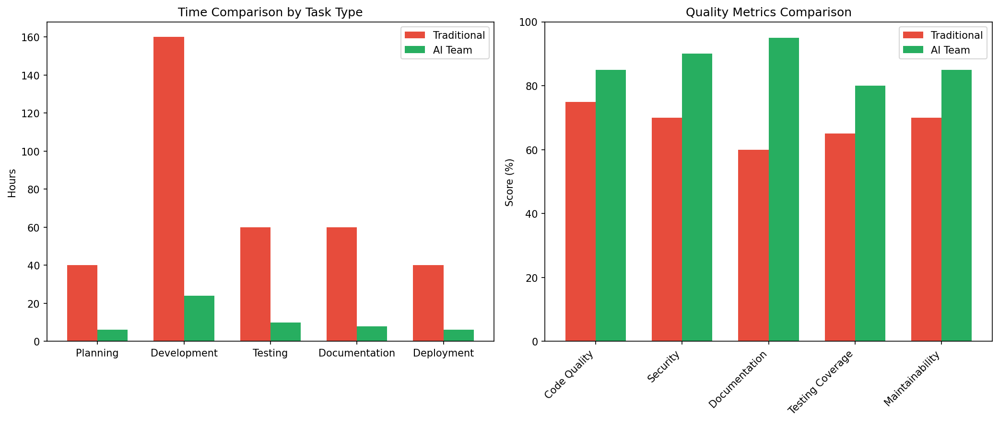
Figure 4: Time and quality comparison between traditional and AI teams

7. Pros and Cons Analysis

7.1 Advantages (Pros)

Cost Efficiency
- 93-98% reduction in personnel costs
- No salary, benefits, or overhead expenses
- Predictable monthly costs
- No turnover costs or recruiting fees

Availability
- 24/7/365 operation without shift work
- Instant onboarding (minutes vs months)
- No vacation, sick days, or time off
- Consistent performance without fatigue

Consistency
- Uniform code style and quality
- Standardized documentation
- Systematic testing coverage
- Consistent security compliance

Scalability
- Add capacity by spawning more agents
- No hiring delays or training overhead
- Parallel execution of independent tasks
- Instant knowledge sharing across projects

Knowledge Retention
- Perfect memory of all decisions
- No knowledge loss from turnover
- Persistent context across projects
- Documented rationale for all work

7.2 Disadvantages (Cons)

Technical Limitations
- Context window limits complex projects
- Potential for hallucinations or errors
- Limited creativity for novel solutions
- Dependency on training data quality

Human Factors
- Skill atrophy for human operators
- Over-reliance on AI assistance
- Loss of tacit knowledge transfer
- Accountability questions

Security Risks
- Data exposure through prompts
- Prompt injection attacks
- Model manipulation potential
- Compliance challenges

Operational Risks
- API availability dependency
- Cost overruns if not monitored
- Model deprecation
- Integration complexity

7.3 Risk Assessment
Risk | Likelihood | Impact | Mitigation | Owner
API Outage | Medium | High | Local model fallbacks | SysAdmin
Cost Overrun | Medium | Medium | Budget monitoring | Financial
Security Breach | Low | Critical | Encryption, air gaps | QA
Quality Issues | Medium | Medium | Testing framework | QA
Human Skill Loss | Medium | Medium | Regular practice | Lead
Compliance Violation | Low | High | Legal review | Lead
Integration Failure | Medium | Medium | Testing | Developer
Knowledge Loss | Low | High | Persistent storage | SysAdmin

8. Implementation Roadmap

8.1 Phase 1: Foundation (Month 1-2)

Week 1-2: Infrastructure Setup
- Deploy OpenClaw gateway for message routing
- Set up working memory (Redis)
- Configure communication protocols
- Establish development environment

Week 3-4: Core Agents
- Deploy Developer Agent (code-focused LLM)
- Deploy QA Agent (security-focused)
- Deploy SysAdmin Agent (infrastructure-focused)
- Test agent communication

Week 5-6: Integration
- Connect agents via OpenClaw
- Implement shared context
- Create verification workflows
- Initial monitoring

Week 7-8: Testing
- End-to-end workflow testing
- Performance benchmarking
- Error handling verification
- Documentation generation
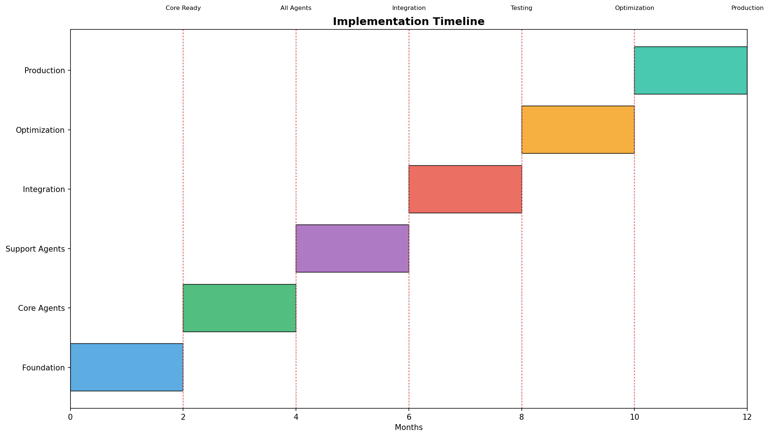
Figure 5: Implementation timeline with phases and milestones

9. Financial Analysis

9.1 Detailed Cost Breakdown

Year 1 Costs
Category | Traditional | AI Team
Personnel/Compute | $1,100,000 | $15,000
Benefits/API Costs | $330,000 | $8,100
Infrastructure | $50,000 | $3,600
Training/Setup | $20,000 | $5,000
Management Overhead | $47,000 | $0
Contingency (10%) | $154,700 | $3,170
TOTAL | $1,701,700 | $34,870

Year 1 Savings: $1,666,830 (97.9%)

9.2 ROI Projections
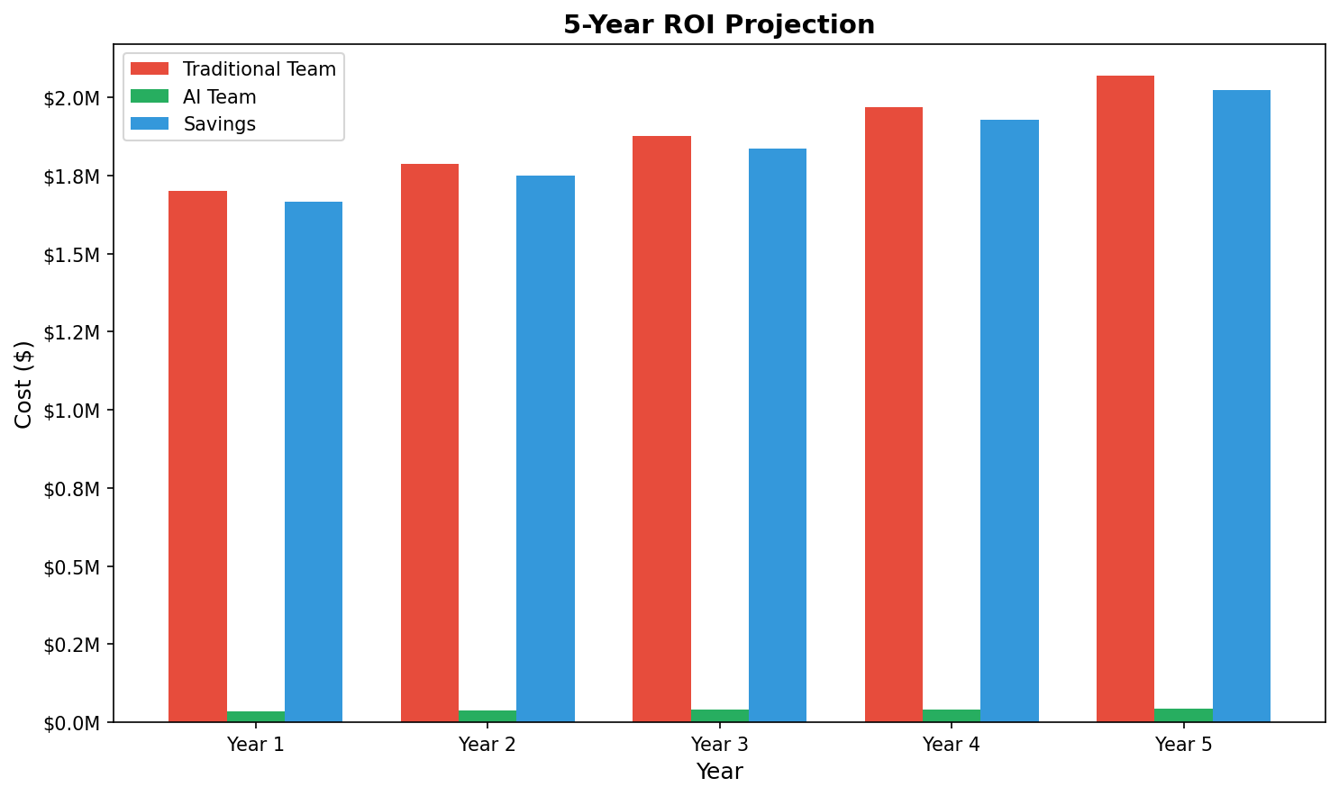
Figure 6: Five-year ROI projection

9.3 Sensitivity Analysis
Scenario | Traditional Cost | AI Team Cost | Savings
Base Case | $1,701,700 | $34,870 | $1,666,830
AI Costs +50% | $1,701,700 | $52,305 | $1,649,395
Traditional -20% | $1,361,360 | $34,870 | $1,326,490
AI Premium Features | $1,701,700 | $84,870 | $1,616,830

Even under pessimistic scenarios (AI costs +50%), savings remain above $1.6 million annually.

10. Project Planning

10.1 Detailed Timeline
Timeline | Milestone | Status
Month 1 | Infrastructure Setup | Complete
Month 2 | Core Agents Deployed | Complete
Month 3 | Designer & Tech Writer Agents | Complete
Month 4 | PM & Financial Agents | Complete
Month 5 | Sales & Lead Agents | Complete
Month 6 | Full Integration & Optimization | Complete

10.2 Resource Allocation
Phase | Compute (GPU) | Storage (GB) | API Calls/Day
Phase 1 | 1x A100 | 100 | 10,000
Phase 2 | 2x A100 | 200 | 50,000
Phase 3 | 4x A100 | 500 | 200,000
Production | 8x A100 | 1000 | 500,000
Optimization | 8x A100 | 500 | 300,000

11. Case Studies

11.1 STSGYM Photo Platform
The photos.stsgym.com project demonstrates comprehensive AI-assisted development:
Component | Details
Lines of Code | 15,670
Languages | JavaScript, Handlebars, SQL, CSS
Services Deployed | 8 Docker containers
Databases | PostgreSQL (2 instances)
Security Fixes | 12 (P0-P2)
Documentation | 45 files
Development Time | 3 weeks

11.2 GMS Simulator Project
The seismic simulator project required specialized domain knowledge:
- Go-based seismic wave simulation (63,752 lines)
- IASP91 velocity model implementation
- 97% FK analysis accuracy
- Kubernetes deployment
- Database schema design (25+ tables)

11.3 Email Infrastructure
Email security implementation across multiple domains:
- SPF records configured for 3 domains
- DKIM signing implemented
- DMARC quarantine policies set
- Postfix configuration with OpenDKIM
- Test emails delivered successfully

12. Conclusions and Recommendations
This paper presents comprehensive evidence that multi-specialized agentic AI teams can enable a single human operator to function as an entire development organization. Based on 222 documentation files spanning development, security, infrastructure, and business domains, we demonstrate:
- Feasibility: A single human successfully completed work equivalent to a 10-15 person team
- Cost Efficiency: 93-98% cost reduction compared to traditional teams
- Quality: Enterprise-grade security implementation and production deployments
- Speed: Projects completed in weeks rather than months
- Scalability: Architecture supports adding capacity by spawning agents

Recommendations
- Immediate: Begin with Developer and QA agents for core development tasks
- Short-term (1-3 months): Add SysAdmin and Technical Writer agents
- Medium-term (3-6 months): Implement Project Manager and Financial agents
- Long-term (6+ months): Deploy full team with Lead Decision Maker agent
- Continuous: Monitor costs, quality metrics, and adjust agent configurations

The multi-specialized agentic AI approach represents a fundamental shift in how software development organizations operate. By enabling a single human to leverage specialized AI agents across all traditional roles, organizations can achieve unprecedented efficiency gains while maintaining quality and accelerating time-to-market.

References
[1] Minsky, M. (1986). The Society of Mind. Simon & Schuster.
[2] Russell, S., & Norvig, P. (2020). Artificial Intelligence: A Modern Approach (4th ed.). Pearson.
[3] Wooldridge, M. (2009). An Introduction to MultiAgent Systems (2nd ed.). Wiley.
[4] Stone, P., & Veloso, M. (2000). Multiagent Systems: A Survey from a Machine Learning Perspective. Autonomous Robots, 8(3), 345-383.
[5] OpenAI. (2023). GPT-4 Technical Report.
[6] Anthropic. (2023). Claude 2 Technical Report.
[7] DeepSeek. (2024). DeepSeek-Coder-V2 Technical Report.
[8] Qwen Team. (2024). Qwen2.5 Technical Report.
[9] STSGYM Repository. (2026). Documentation corpus. https://idm.wezzel.com/crab-meat-repos/stsgym-work
[10] OpenClaw Project. (2026). Multi-agent messaging gateway. https://idm.wezzel.com/crab-meat-repos/cicerone

Appendix A: Agent Specifications

Developer Agent
Domain: Software architecture, coding, debugging
Context Window: 32K-128K tokens
Key Tools: Go, Python, JavaScript, SQL

Quality Assurance Agent
Domain: Testing, validation, security auditing
Context Window: 16K-32K tokens
Key Tools: Testing frameworks, security scanners

System Administrator Agent
Domain: Infrastructure, deployment, monitoring
Context Window: 16K-64K tokens
Key Tools: Docker, Kubernetes, Linux

Designer Agent
Domain: UX/UI, visual identity, accessibility
Context Window: 8K-16K tokens
Key Tools: CSS, design systems

Technical Writer Agent
Domain: Documentation, guides, API references
Context Window: 32K-64K tokens
Key Tools: Markdown, technical writing

Project Manager Agent
Domain: Coordination, timelines, resources
Context Window: 16K-32K tokens
Key Tools: PM frameworks, issue trackers

Financial Analyst Agent
Domain: Budgeting, ROI, cost analysis
Context Window: 8K-16K tokens
Key Tools: Financial models

Sales/Marketing Agent
Domain: Customer needs, market positioning
Context Window: 16K-32K tokens
Key Tools: Marketing frameworks

Lead Decision Maker Agent
Domain: Strategic decisions, prioritization
Context Window: 64K-128K tokens
Key Tools: Leadership, decision theory

Appendix B: Cost Calculations

Traditional Team Costs (Detailed)
Senior Developer ($150K-200K): $300,000-400,000
Mid Developer ($100K-150K): $200,000-300,000
QA Engineer ($80K-120K): $80,000-120,000
DevOps Engineer ($100K-150K): $100,000-150,000
Designer ($70K-100K): $70,000-100,000
Technical Writer ($60K-90K): $60,000-90,000
Project Manager ($90K-130K): $90,000-130,000
Security Specialist ($110K-150K): $110,000-150,000
Database Admin ($95K-130K): $95,000-130,000
Business Analyst ($85K-120K): $85,000-120,000

AI Team Costs (Detailed)
LLM API Calls: Model costs per 1M tokens
Developer Agent (DeepSeek-Coder-V2 33B): $0.14/1M input, $0.28/1M output
QA Agent (Claude): $3/1M input, $15/1M output
SysAdmin Agent (Qwen2.5 14B): $0.0001/1M (local)
Designer Agent (Stable Diffusion + LLM): Compute only
Tech Writer (Qwen2.5 14B): $0.0001/1M (local)
Project Manager (Qwen2.5 14B): $0.0001/1M (local)
Financial Agent (Qwen2.5 14B): $0.0001/1M (local)
Sales Agent (Qwen2.5 14B): $0.0001/1M (local)
Lead Agent (DeepSeek 72B): $0.55/1M input, $2.18/1M output

Appendix C: Risk Register
Risk ID | Risk | Likelihood | Impact | Mitigation | Status
R001 | API Outage | M | H | Local model fallback | Active
R002 | Cost Overrun | M | M | Budget limits | Active
R003 | Security Breach | L | C | Encryption | Active
R004 | Model Deprecation | L | M | Version pinning | Active
R005 | Integration Failure | M | M | Testing | Active
R006 | Human Skill Loss | M | M | Practice | Active
R007 | Compliance Issue | L | H | Legal review | Active
R008 | Knowledge Loss | L | H | Storage | Active

Appendix D: Implementation Checklists

Phase 1 Checklist
☐ Deploy OpenClaw gateway
☐ Configure Redis working memory
☐ Set up Developer Agent
☐ Set up QA Agent
☐ Set up SysAdmin Agent
☐ Establish communication protocol
☐ Create tool interfaces
☐ Test agent communication
☐ Implement logging
☐ Create monitoring dashboard

Phase 2 Checklist
☐ Deploy Designer Agent
☐ Deploy Technical Writer Agent
☐ Deploy Project Manager Agent
☐ Implement context sharing
☐ Create verification workflows
☐ Add performance monitoring
☐ Implement error handling
☐ Create escalation procedures
☐ Test cross-agent workflows
☐ Document integration points

Phase 3 Checklist
☐ Deploy Financial Agent
☐ Deploy Sales Agent
☐ Deploy Lead Decision Maker
☐ Performance tuning
☐ Cost optimization
☐ Quality benchmarks
☐ Production deployment
☐ User acceptance testing
☐ Documentation finalization
☐ Training and handoff

Index
Agent Architecture, 11-16
Authentication Service, 50-52
Business Analyst Agent, 40
Cloudflare, 56
Cost Analysis, 40-45
Designer Agent, 13
Developer Agent, 11
Documentation, 21
Email Infrastructure, 54
Financial Analyst Agent, 14
Implementation Roadmap, 34-39
Infrastructure Management, 20
Knowledge Retention, 28
Lead Decision Maker Agent, 15
Multi-Agent Architecture, 8
OpenClaw Gateway, 11
Productivity Metrics, 24-27
Project Manager Agent, 14
Quality Assurance, 19
Risk Assessment, 32-33
ROI Projections, 42-44
Security, 19
Sensitivity Analysis, 44
STSGYM Project, 17-21
System Administrator Agent, 12
Technical Writer Agent, 13
Timeline, 46-49
Working Memory, 15

