RF Frequency Analysis Hardware Kit
Medium Grade - Off-the-Shelf Components
Date: March 23, 2026

Table of Contents
1. Executive Summary 3
2. Hardware Tier Comparison 4
3. Recommended Kit Configuration 5
4. Phased Implementation Plan 6
5. Software Stack 7
6. Frequency Analysis Workflow 8
7. Budget Summary 9
8. Learning Resources 10
9. Safety and Legal Considerations 11
10. Conclusion 12

1. Executive Summary
This document outlines a comprehensive roadmap for building a medium-grade radio frequency (RF) analysis hardware kit using off-the-shelf components. The kit is designed for users transitioning from beginner to intermediate level, providing professional-grade capabilities at reasonable cost.
The recommended configuration centers on the HackRF One, providing full duplex (TX+RX) capability across 1 MHz to 6 GHz with 20 MHz instantaneous bandwidth. Total investment of $1,000 provides professional-grade analysis capability with a phased implementation approach.

Key Specifications
Specification | Value
Frequency Range | 1 MHz - 6 GHz
Bandwidth | Up to 20 MHz
TX Power | 0 to +15 dBm
Sample Rate | 20 MSPS (8-bit I/Q)
Total Budget | $1,000 (phased)
Implementation | 16 weeks

2. Hardware Tier Comparison

Tier 1: Entry Level (Beginner)
Device | Frequency | Bandwidth | Price | Best For
RTL-SDR V3 | 24-1766 MHz | 2.4 MHz | $35 | Learning
RTL-SDR V4 | 500k-1.7 GHz | 2.4 MHz | $45 | HF + VHF/UHF
Nooelec SMArTee | 24-1766 MHz | 2.4 MHz | $40 | Low noise

Tier 2: Medium Grade (Intermediate) - RECOMMENDED
Device | Frequency | Bandwidth | TX Power | Price
HackRF One | 1-6000 MHz | 20 MHz | 0-15 dBm | $300
LimeSDR | 100k-3.8 GHz | 61.4 MHz | Up to 10 dBm | $300
LimeSDR Mini | 10M-3.5 GHz | 30.7 MHz | Up to 10 dBm | $150
BladeRF x40 | 300M-3.8 GHz | 28 MHz | Up to 6 dBm | $400

Tier 3: Professional Grade (Advanced)
Device | Frequency | Bandwidth | Price
Ettus USRP B210 | 70M-6 GHz | 56 MHz | $1,100
BladeRF 2.0 micro | 47M-6 GHz | 56 MHz | $540
PlutoSDR | 70M-6 GHz | 56 MHz | $230

Frequency Coverage Comparison
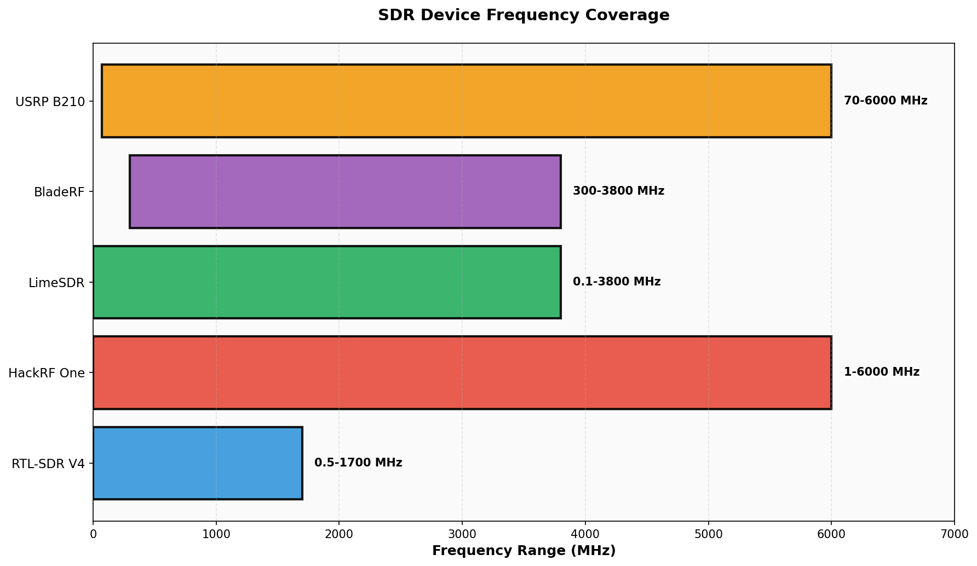
Figure 1: Frequency range comparison across SDR devices.

Price vs Bandwidth Comparison
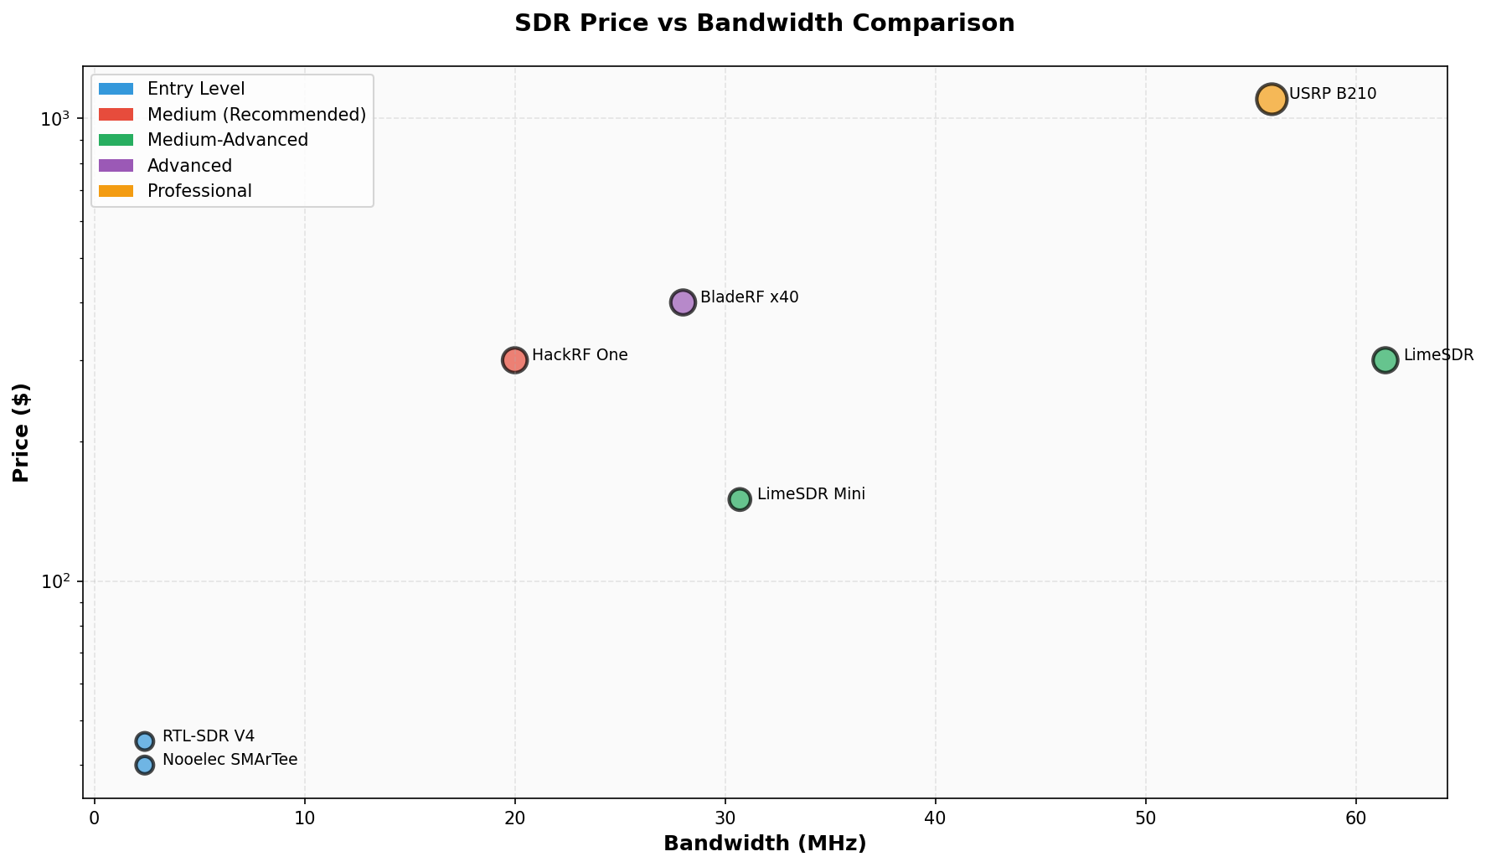
Figure 2: Price versus bandwidth for different SDR platforms.

3. Recommended Kit Configuration

Primary Device: HackRF One ($300)
Specification | Value
Frequency Range | 1 MHz - 6 GHz
Operating Modes | Half-duplex (TX or RX)
RF Bandwidth | Up to 20 MHz
Sample Rate | 20 MSPS (8-bit I/Q)
TX Power | 0 to +15 dBm typical
RX Sensitivity | -80 dBm typical
Interface | USB 2.0
Antenna Connector | SMA female

Why HackRF One: Widest frequency range (1 MHz - 6 GHz), transmit AND receive capability, massive community support, open source hardware, excellent documentation and tutorials.

Supporting Equipment
Category | Items | Budget
Antennas | Dipole kit, Discone, Log Periodic | $100-150
Cables/Adapters | SMA cables, BNC/N adapters, Attenuators | $50
Accessories | USB hub, Case, LNA, Bias-tee, TCXO | $80-150
Computing | Laptop (i5+, 8GB RAM, USB 3.0) | $200-500

Capability Comparison
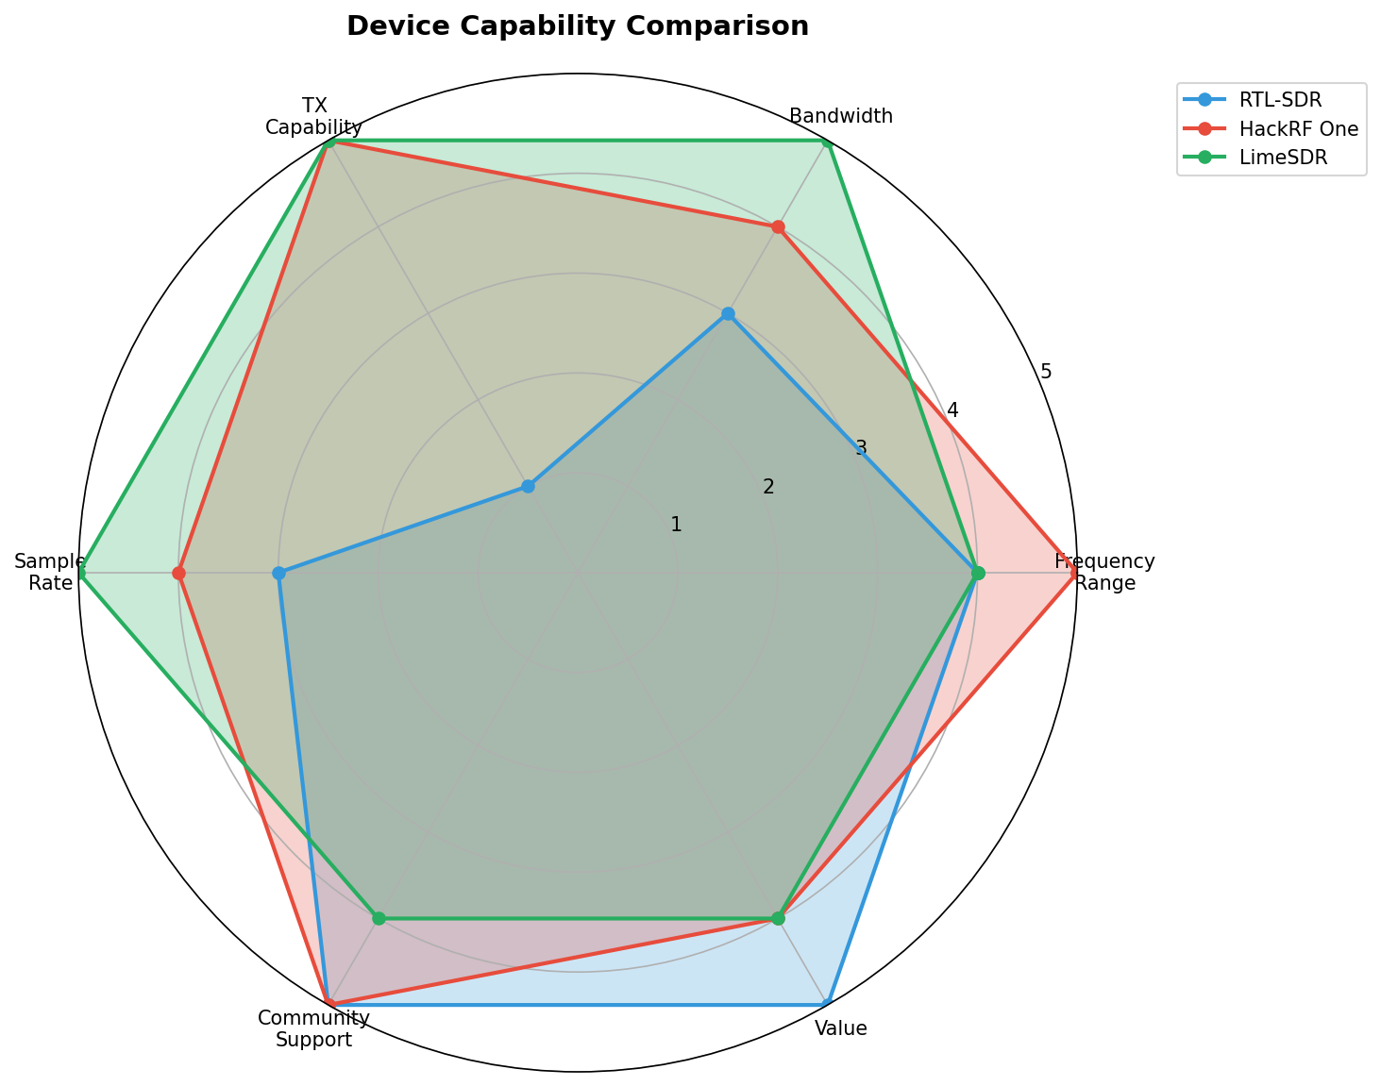
Figure 3: Radar chart comparing device capabilities across key metrics.

4. Phased Implementation Plan
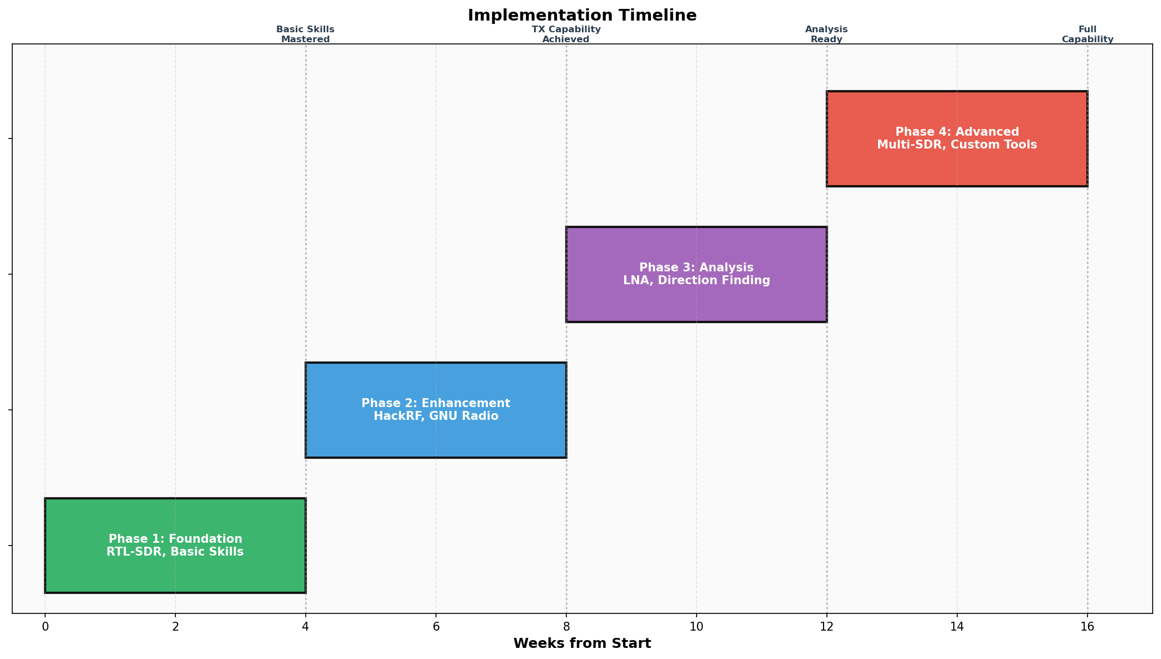
Figure 4: 16-week implementation timeline with milestones.

Phase 1: Foundation (Weeks 1-4) - $100
Equipment | Cost
RTL-SDR Blog V4 dongle | $45
Basic dipole antenna kit | $25
USB cable, SMA adapters | $30

Skills: Software installation, frequency scanning, signal identification, recording

Phase 2: Enhancement (Weeks 5-8) - $400
Equipment | Cost
HackRF One | $300
Discone antenna | $80
USB 3.0 hub | $25

Skills: Transmitting signals, GNU Radio basics, modulation analysis

Phase 3: Analysis (Weeks 9-12) - $200
Equipment | Cost
LNA with bias-tee | $60
Better cables and adapters | $50
Directional antenna | $60
TCXO upgrade | $30

Skills: Weak signal reception, direction finding, regulatory compliance

Phase 4: Advanced (Weeks 13-16) - $300
Equipment | Cost
Second SDR (diversity) | $45
Shielded enclosure | $50
GPSDO for timing (optional) | $200

Skills: Coherent reception, advanced GNU Radio, security testing

5. Software Stack

Core Analysis Software
Software | Platform | Purpose | License
GQRX | Linux/Mac | General receiver | GPL
SDR++ | Cross-platform | Wideband receiver | GPL
SDR-Angel | Windows/Linux | Multi-mode receiver | GPL
CubicSDR | Cross-platform | Visual spectrum | BSD
GNU Radio | Cross-platform | DSP framework | GPL

Specialized Tools
Software | Purpose
URH (Universal Radio Hacker) | Protocol analysis
SigDigger | Signal analysis
Baudline | Spectral analysis
Fosphor | GPU-accelerated waterfall
QSpectrumAnalyzer | Python spectrum analyzer

6. Budget Summary
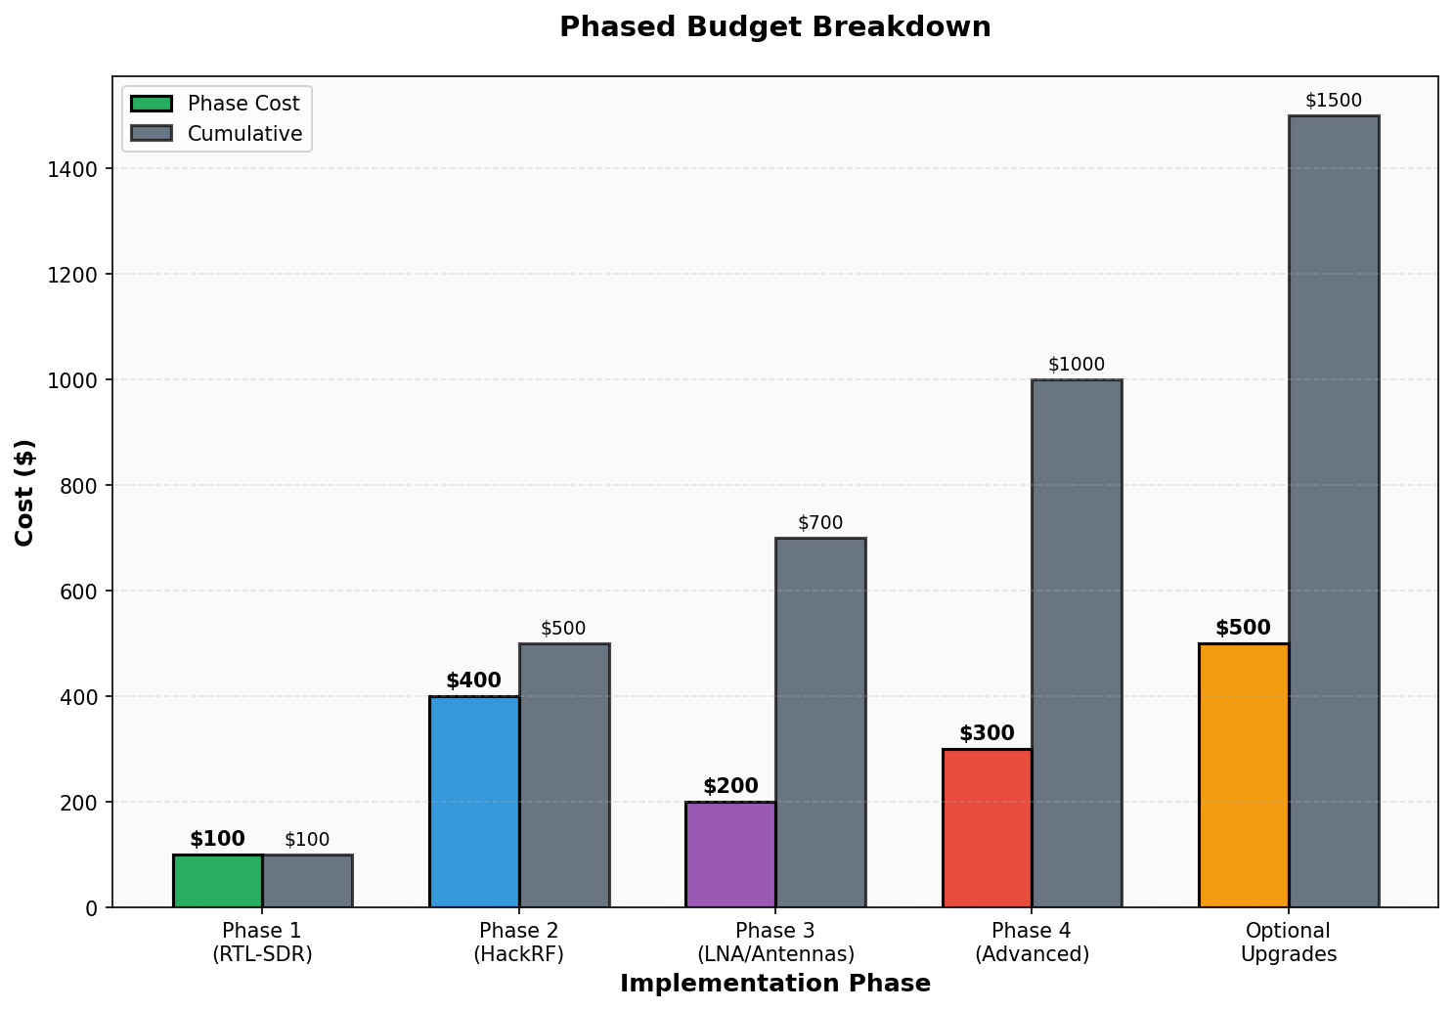
Figure 5: Phased budget breakdown with cumulative costs.
Phase | Equipment | Cost
Phase 1 | RTL-SDR kit | $100
Phase 2 | HackRF One + antenna | $400
Phase 3 | LNA, adapters, directional | $200
Phase 4 | Second SDR, shielding | $300
Total |  | $1,000

Budget Options
Configuration | Total Cost | Capability
Minimum Viable | $450 | RTL-SDR + HackRF
Medium-Grade | $1,000 | All 4 phases
Optimal | $1,500 | With upgrades

7. Learning Resources

Free Resources
Resource | URL | Focus
RTL-SDR.com | rtl-sdr.com | Beginner tutorials
Great Scott Gadgets | greatscottgadgets.com/sdr | Video series
GNU Radio Tutorials | tutorials.gnuradio.org | DSP fundamentals
Signal Identification Wiki | sigidwiki.com | Signal database
Radio Reference | radioreference.com | Frequency database

Recommended Books
Book | Author | Price
SDR for Engineers | Analog Devices | Free PDF
GNU Radio Cookbook | Various | Free online
Signals and Systems | Oppenheim | $120

8. Safety and Legal Considerations

Transmit Restrictions
Band | TX Allowed? | License Required
AM Broadcast | NO | N/A
FM Broadcast | NO | N/A
Amateur Radio | YES | Amateur license
ISM Bands (315/433/915 MHz) | YES | Part 15 compliant
Citizen's Band | YES | None (Part 95)
FRS/GMRS | Partial | GMRS requires license

Best Practices
- 1. Never transmit on restricted frequencies
- 2. Use attenuators when testing near transmitters
- 3. Obtain proper licenses before TX
- 4. Keep records of all transmissions
- 5. Respect privacy - do not decode private communications

9. Conclusion
A medium-grade RF analysis kit centered on the HackRF One provides excellent value for intermediate users. The phased approach allows gradual skill development while building capability. Total investment of $1,000 provides professional-grade analysis capability across 1 MHz to 6 GHz with both transmit and receive functionality.
Key recommendations:
- Start with RTL-SDR for learning ($45-100)
- Upgrade to HackRF One for TX capability ($300)
- Add LNA and better antennas for weak signals ($100)
- Expand to multi-SDR setups for advanced analysis ($300+)
This kit provides the foundation for RF spectrum analysis, signal identification, protocol reverse engineering, security testing (authorized), amateur radio operation, and regulatory compliance verification.

Appendix: Vendor List
Vendor | Products | Website
RTL-SDR Blog | RTL-SDR V3/V4 | rtl-sdr.com
Nooelec | NESDR series | nooelec.com
Great Scott Gadgets | HackRF | greatscottgadgets.com
Lime Microsystems | LimeSDR | limemicro.com
Nuand | BladeRF | nuand.com
Ettus Research | USRP | ettus.com

